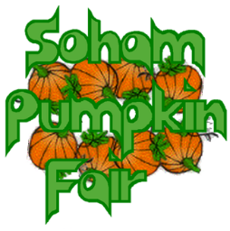
Dear Supporter,

Thank you for showing an interest in the Soham Pumpkin Fair.

The money we raise for our charities is always with the support of local organisations and businesses either through sponsoring prizes for the competitions on the day, by advertising in the brochure, or by hiring one of our market stalls. Last year, we were able to raise £4000 for our chosen beneficiaries: Arthur rank hospice, 2nd Soham Rainbows, 2nd Soham Brownies, Ely baby bank and VCAEC helping hands gardening team.
Our chosen beneficiaries for this year are:

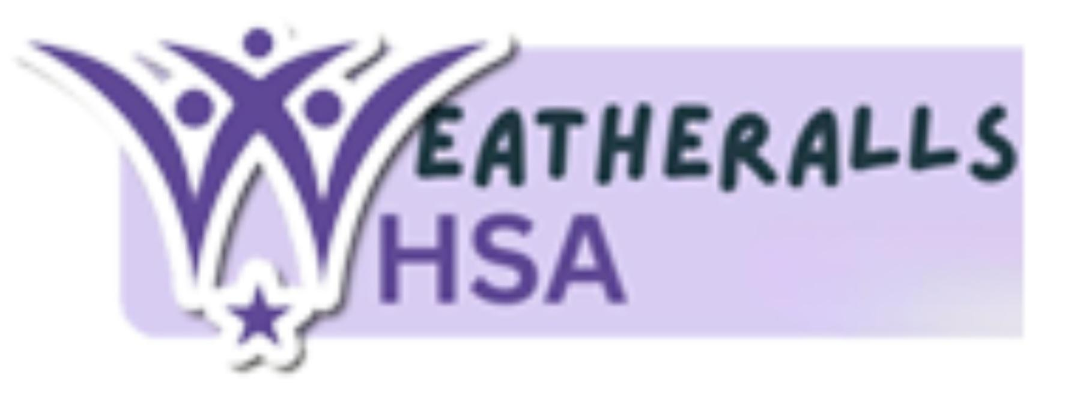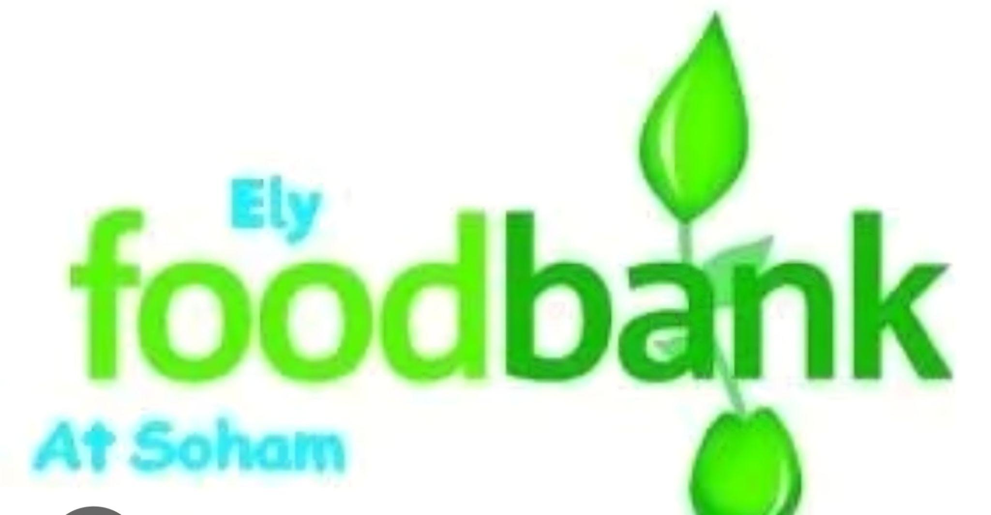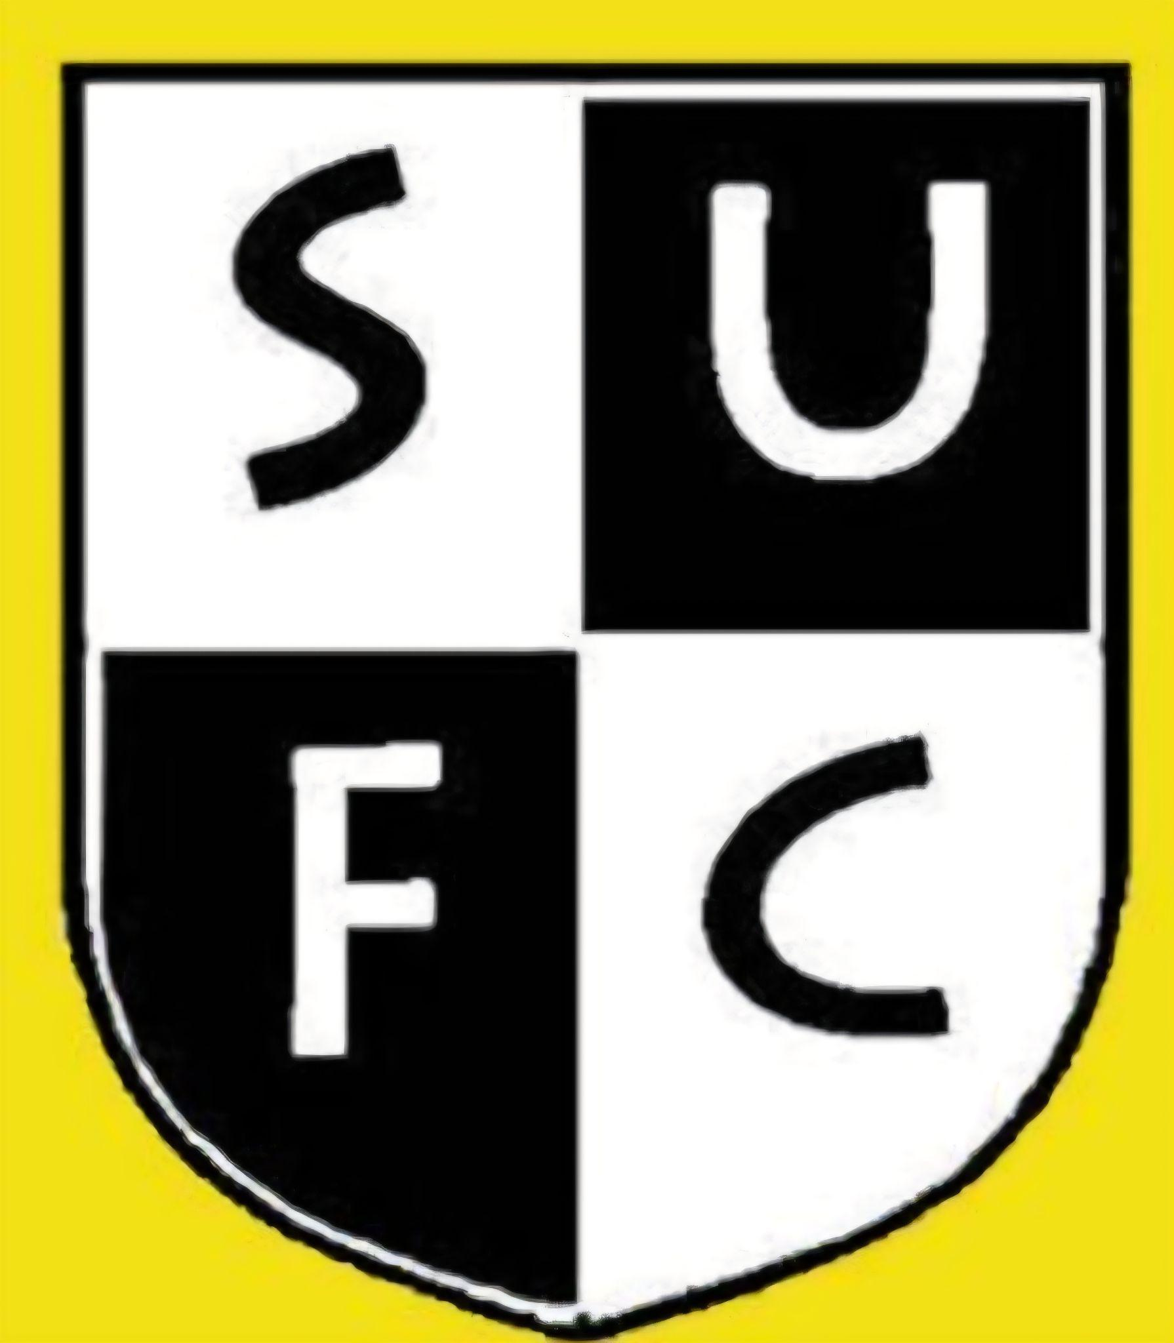

This year the Pumpkin Fair will take place on Saturday 26th September 2026 and our theme is Pumpkins of the Caribbean

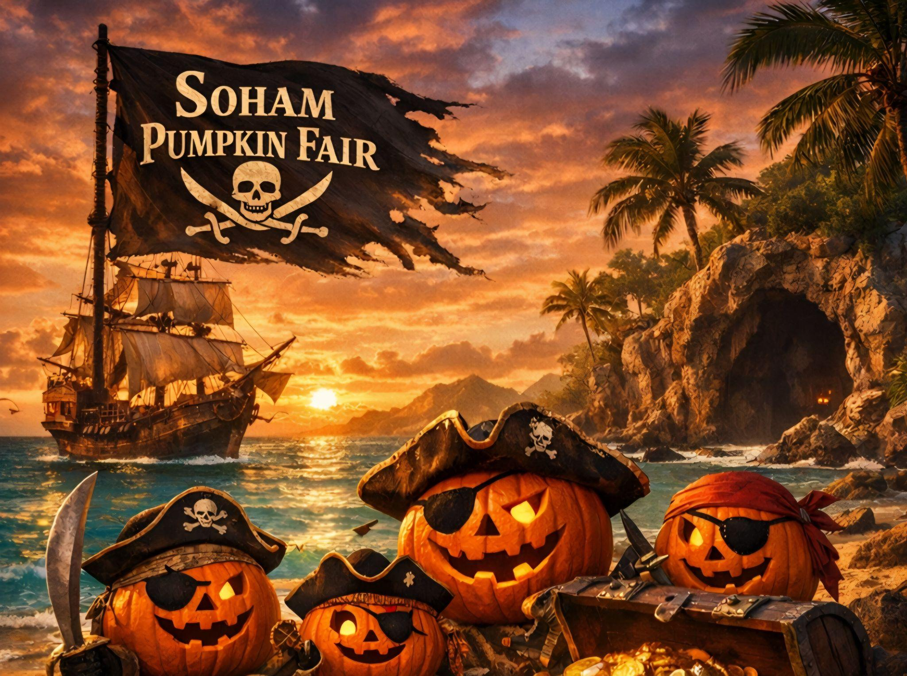

The brochure which contains information about our competitions, previous winners and beneficiaries together with What’s On at the fair, is distributed electronically to every pupil in our Soham schools and made available on our Facebook page and website. Also, paper copies are distributed to local businesses, shops and libraries etc.
With all this in mind, I am writing to ask you to consider placing an advert in our brochure, which enables us to raise more money on the day. Alternatively you may wish to sponsor the fair.
If you wish to place an advert, please complete the attached form by email and you can pay by BACS (alternatively return by post together with your cheque) Copy for your advert and payment need to be with us by 15th July 2026. For further information regarding placing an advert or sponsorship please contact us at Soham.pumpkin.fair@gmail.com
We do hope you will be able to support this year’s Fair.
You can find more details of our event on our website: www.sohampumpkinfair.co.uk
Yours sincerely,
Soham pumpkin fair committee

If you would like to place an advertisement in the Pumpkin Fair Brochure, please tick the box for the size you want and return this form by email, along with the artwork for your advert to: soham.pumpkin.fair@gmail.com

Preferred payment is paying by BACS – please ask for details by emailing
Soham.pumpkin.fair@gmail.com

Full Page Ad (portrait) £110.00

Qtr Page Ad (portrait) £50.00

Half Page Ad (landscape) £70.00

Alternatively print and complete the form and post (together with your cheque made payable to Soham Pumpkin Fair) for the agreed amount to:
Please submit your artwork in one of the following formats:
MS Word
MS Publisher
JPEG
PDF

Michelle Harrison,
Soham Pumpkin Fair
10, Queensway
Soham, Ely, Cambs. CB7 5BX

Business Name _____________________________________________________________________________

Phone Number/s ____________________________________________________________________________

Contact Name ______________________________________________________________________________

Address ___________________________________________________________________________________

__________________________________________________________________________________________

e-mail ____________________________________________________________________________________

Signature ________________________________________________________Date _____________________

